Entity Model

📝Definition
# Source: AI Source: Provided by: [Data Path: Persons Table -> ID Column: 1, Name_En Column: Motasem Essam] -> From: [ChatGPT] on [1/23/2026]
The Entity Model represents objects that have a unique identity and exist independently over time, even if their data changes.
👉 An Entity is defined by who it is (ID), not just what it contains (data)

🔑 Key Characteristics
# Source: AI Source: Provided by: [Data Path: Persons Table -> ID Column: 1, Name_En Column: Motasem Essam] -> From: [ChatGPT] on [1/23/2026]
- Has a unique identifier (ID)
- Has a lifecycle (created → updated → deleted)
- Can change state over time
- Represents a real-world concept

🧱 Example
# Source: AI Source: Provided by: [Data Path: Persons Table -> ID Column: 1, Name_En Column: Motasem Essam] -> From: [ChatGPT] on [1/23/2026]
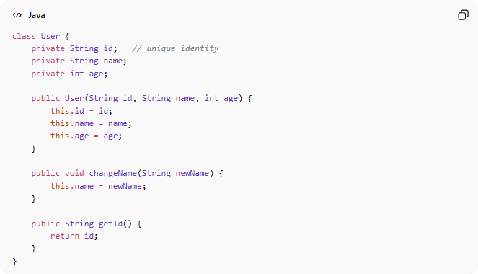
class User {
private String id; // unique identity
private String name;
private int age;

public User(String id, String name, int age) {
this.id = id;
this.name = name;
this.age = age;
}

public void changeName(String newName) {
this.name = newName;
}

public String getId() {
return id;
}
}
👉 Even if name or age changes → it is still the same User because of id

🔄 Entity Identity Example
# Source: AI Source: Provided by: [Data Path: Persons Table -> ID Column: 1, Name_En Column: Motasem Essam] -> From: [ChatGPT] on [1/23/2026]
User(id=1, name="Ali") → change name → User(id=1, name="Omar")
👉 Same entity (same ID), different state

❌ Bad Example (Weak Entity)
# Source: AI Source: Provided by: [Data Path: Persons Table -> ID Column: 1, Name_En Column: Motasem Essam] -> From: [ChatGPT] on [1/23/2026]
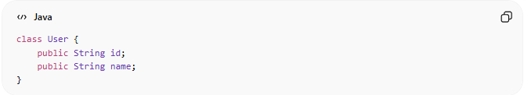
class User {
public String id;
public String name;
}
👉 Problems:
- No encapsulation
- No behavior
- Just a data container

✅ Good Example (Rich Entity)
# Source: AI Source: Provided by: [Data Path: Persons Table -> ID Column: 1, Name_En Column: Motasem Essam] -> From: [ChatGPT] on [1/23/2026]
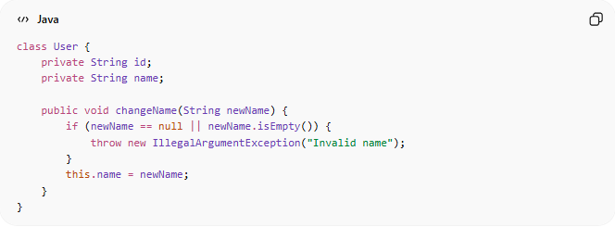
class User {
private String id;
private String name;

public void changeName(String newName) {
if (newName == null || newName.isEmpty()) {
throw new IllegalArgumentException("Invalid name");
}
this.name = newName;
}
}
👉 Benefits:
- Encapsulation
- Business rules inside entity
- Safer and maintainable

🔄 Entity vs Other Models
# Source: AI Source: Provided by: [Data Path: Persons Table -> ID Column: 1, Name_En Column: Motasem Essam] -> From: [ChatGPT] on [1/23/2026]
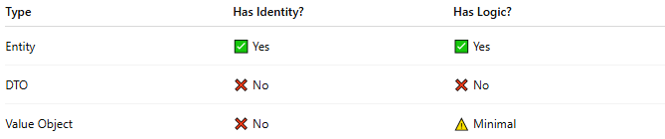
Type | Has Identity? | Has Logic?
Entity | ✅ Yes | ✅ Yes
DTO | ❌ No | ❌ No
Value Object | ❌ No | ⚠️ Minimal

⚠️ Common Mistakes
# Source: AI Source: Provided by: [Data Path: Persons Table -> ID Column: 1, Name_En Column: Motasem Essam] -> From: [ChatGPT] on [1/23/2026]
- Treating Entity as just a DTO ❌
- Putting business logic outside the Entity ❌
- Not defining a clear ID ❌

💡 Key Idea
# Source: AI Source: Provided by: [Data Path: Persons Table -> ID Column: 1, Name_En Column: Motasem Essam] -> From: [ChatGPT] on [1/23/2026]
Entity = Identity + Behavior + Lifecycle

🧾 Summary
# Source: AI Source: Provided by: [Data Path: Persons Table -> ID Column: 1, Name_En Column: Motasem Essam] -> From: [ChatGPT] on [1/23/2026]
The Entity Model:
- Represents real-world objects
- Has a unique identity
- Can change over time
- Contains data and behavior

